Repo: looking to purge artifacts from:
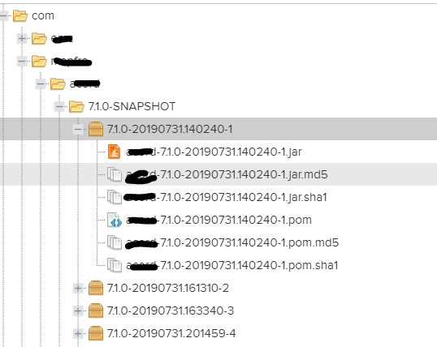

What API returns for data
"name": "libs-snapshot-local",
"format": "maven2",
"type": "hosted",
"url": "https://ourcompanyrepo/repository/libs-snapshot-local"
},
"downloadUrl": "https:// ourcompanyrepo /repository/libs-snapshot-local/com/company/appName/appName2/19.5-SNAPSHOT/AppName2-19.5-20190305.171327-1.war",
"path": "com/company/appName/appName2/19.5-SNAPSHOT/AppName2-19.5-20190305.171327-1.war",
"id": "id number",
"repository": "libs-snapshot-local",
"format": "maven2",

